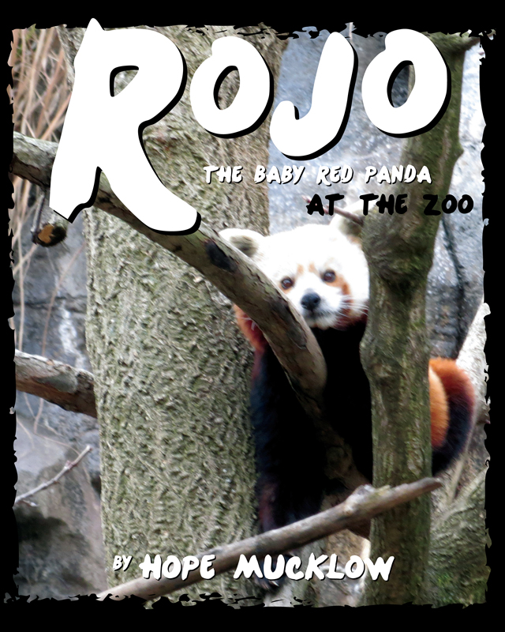

This is Hope Mucklow’s first book. She weaves life lessons throughout this allegory that she is still learning concerning one’s self-perception and attitudes to encourage individuals to embrace who they are and to enjoy all that they can become.

Enjoy the beauty of the red pandas from the National Zoo as a mother to daughter story compares them to the giant pandas in an allegory about self-worth in the eyes of their creator.

Author Hope Mucklow is available for book signings and readings. Contact her at hope_mucklow@yahoo.com.

Rojo the Baby Red Panda at the Zoo

By Hope Mucklow

ISBN-10: 1620865939

ISBN-13: 9781620865934

Retail Price: $14.95

Release Date: 12/12/2014